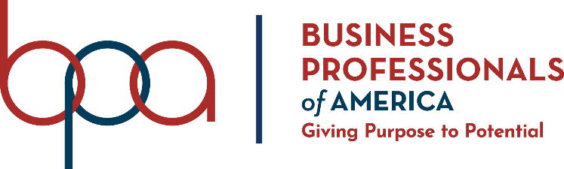

EXTEMPORANEOUS SPEECH
(525)

STATE – 2020
PRELIMNARY

Judges/Graders: Please double check and verify all scores and answer keys!

Property of Business Professionals of America.
May be reproduced only for use in the Business Professionals of America
Workplace Skills Assessment Program competition.

TOPICS:

How do you define success?
Which is more important: learning from mistakes or doing it right the first time?
How would you convince someone else to join BPA?
What is your favorite BPA competitive event, and why?
If you had to add one competitive event to BPA next year, what would it be and why?
How could you improve your state organization?
Have you ever dealt with a school policy you weren't in agreement with? How?
Describe ways to help a team avoid digital distractions.

